Next Gen. Database System Project

**NAME:** ABHYUDAYA AGRAWAL

**ROLL NO.:** 205223001

**CLASS:** M.Tech 1st year (Data Analytics)

**SUBJECT:** Next Gen. Database System

**PROBLEM STATEMENT**

**Laundry Management System** in NIT-T Campus.

**Background:**

Laundry facilities are essential services at NIT-T Campus. Managing laundry operations efficiently and providing customers with timely status updates on their laundry orders is a challenge for laundry service providers. To address this, I aim to develop a Laundry Management System (LMS) that streamlines laundry operations, enhances customer experience, and ensures a smooth and efficient laundry processing workflow.

**Problem Description:**

The Laundry Management System seeks to address the following key problems:

**1. Inefficient Laundry Operations:** Many laundry facilities still rely on manual processes, leading to inefficiencies in laundry order management, machine scheduling, and resource allocation.

**2. Lack of Transparency:** Customers often lack real-time information about the status of their laundry orders, leading to frustration and inconvenience.

**3. Order Tracking Challenges:** Tracking the status of laundry orders, from drop-off to pick-up, can be challenging for both customers and service providers.

**Solution Objectives:**

The Laundry Management System aims to achieve the following objectives:

**1. Efficient Operations:** Automate laundry order management, machine scheduling, and resource allocation to optimize laundry processing.

**2. Customer Transparency:** Provide customers with real-time updates on the status of their laundry orders through a user-friendly interface.

**3. Order Tracking:** Enable easy tracking of laundry orders at every stage, from order placement to delivery or pick-up.

**Key Features:**

1. **Place Order:**
   * Users can easily place laundry orders through the system.
   * The system provides a user-friendly interface to select types of clothes, specify quantities, and choose service preferences.
2. **User Authentication:**
   * Secure user authentication ensures that only authorized users can access the system.
   * Users can register, log in, and manage their profiles.
3. **Order Tracking:**
   * Customers can track the status of their laundry orders using a unique reference ID.
   * Real-time updates on the order status provide transparency and convenience.
4. **Admin Dashboard:**
   * An admin dashboard allows staff to manage and monitor all incoming orders.
   * Admins can update order statuses, view customer details, and handle order-related tasks.
5. **Contact Us:**
   * The system includes a contact form for users to reach out with inquiries or support requests.

**Technologies Used:**

* **Frontend:** HTML, Bootstrap
* **Backend:** Flask (Python)
* **Database:** MongoDB for user registration and order management
* **Authentication:** Password hashing for user security
* **Styling:** Bootstrap for a responsive and visually appealing design

**How to Use:**

1. **Place Order:**
   * Visit the "Place Order" page to submit a laundry order, specifying the types of clothes and service preferences.
2. **User Authentication:**
   * New users can register by providing necessary details.
   * Returning users can log in to access their account.
3. **Order Tracking:**
   * Use the "Check Status" page with the reference ID to track the status of a laundry order.
4. **Admin Dashboard:**
   * Admins can log in to the dashboard to manage orders, update statuses, and view customer details.
5. **Contact Us:**
   * Reach out through the "Contact Us" page for any assistance or inquiries.

**Benefits:**

* **Efficiency:** Streamlines the laundry ordering process for both users and service providers.
* **Transparency:** Real-time order tracking enhances customer satisfaction.
* **User-Friendly:** Intuitive interfaces make it easy for users to navigate and interact with the system.
* **Security:** Password hashing ensures the security of user accounts and information.

**List of frameworks, libraries, and dependencies along with their installation instructions:**

Backend (Flask - Python Framework): Flask: Installation: pip install Flask

Flask-PyMongo (for MongoDB integration): Installation: pip install Flask-PyMongo

Passlib (for password hashing): Installation: pip install passlib

Database: MongoDB: Follow the official instructions for installing MongoDB.

**Note:**

Make sure to replace placeholders like 'your_secret_key', 'your-mongodb-url', 'username', and 'password' with your actual values.

**COMPLETE DATABASE SCHEMA**

**1). Table: User Model**

|  |  |  |
| --- | --- | --- |
| Column Name | Data Type | Constraints |
| User_id | **INT** | **PRIMARY KEY, Auto Increment** |
| Username | **VARCHAR(150)** | **UNIQUE, NOT NULL** |
| Password | **VARCHAR(128)** | **NOT NULL** |
| FirstName | **VARCHAR(250)** | **NOT NULL** |
| LastName | **VARCHAR(255)** | **NOT NULL** |
| EMAIL | **VARCHAR(40)** | **UNIQUE, NOT NULL** |
| Phone | **VARCHAR(10)** | **NOT NULL** |
| Address | **VARCHAR(255)** | **NOT NULL** |
| AccountBalance | **DECIMAL(10,2)** | **DEFAULT 0.00** |
|  |  |  |

**2). Table: Orders Model**

|  |  |  |
| --- | --- | --- |
| Column Name | Data Type | Constraints |
| Order_id | **INT** | **PRIMARY KEY, Auto Increment** |
| User_id | **INT** | **NOT NULL, FOREIGN KEY** |
| OrderDate | **DATE** | **NOT NULL** |
| DueDate | **DATE** | **NOT NULL** |
| TotalAmount | **DECIMAL(10,2)** | **NOT NULL** |
| OrderStatus | **VARCHAR(20)** | **NOT NULL (eg. ‘PENDING’, ‘COMPLETED’)** |

**3). Table: Laundry Order Items Model**

|  |  |  |
| --- | --- | --- |
| Column Name | Data Type | Constraints |
| OrderItemID | **INT** | **PRIMARY KEY, AUTO INCREMENT** |
| Order_id | **INT** | **NOT NULL, FOREIGN KEY** |
| LaundryItemID | **INT** | **NOT NULL, FOREIGN KEY** |
| Quantity | **INT** | **NOT NULL, CHECK (QUANTITY >=1)** |
| PricePerUnit | **DECIMAL(10,2)** | **NOT NULL, CHECK (PricePerUnit >=0)** |
| TotalPrice | **DECIMAL(10,2)** | **NOT NULL, CHECK (TotalPrice >=0)** |

**4). Table: Payment Model**

|  |  |  |
| --- | --- | --- |
| Column Name | Data Type | Constraints |
| PaymentID | **INT** | **PRIMARY KEY, AUTO INCREMENT** |
| Order_id | **INT** | **NOT NULL, FOREIGN KEY** |
| PaymentDate | **DATETIME** | **NOT NULL** |
| Amount | **INT** | **NOT NULL** |
| PaymentMethod | **VARCHAR(20)** | **NOT NULL (eg, ‘CASH’)** |
| PaymentStatus | **VARCHAR(20)** | **NOT NULL (eg. ‘PAID’, ‘PENDING’)** |

**ENTITY RELATIONSHIP DIAGRAM**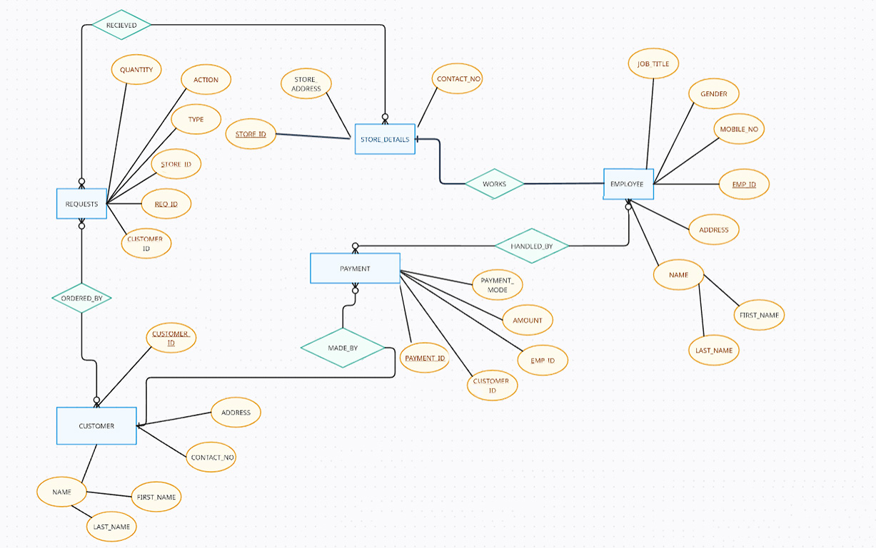

**LIST OF STAKEHOLDERS**

1. **Admin/Owner:**
   * Individuals or entities that oversee the operation of the laundry facility.
2. **Employee:**
   * Staff
3. **Customer:**
   * Students (End Users)

**DATABASE SCHEMA FOR EACH STAKE-HOLDER**

**Admins**:

|  |  |  |
| --- | --- | --- |
| Table Name | Fields | Description |
| Admin | **id** (Primary Key), **username**, **email**, **password, name**... | Information about administrators. |
| Order | **Order_id** (Primary Key), **Customer_id** (Foreign Key),**Amount** , **Order_date**, ... | Contains Details of laundry order |
| Report | **id** (Primary Key), **admin_id** (Foreign Key), **report_text**, **date_generated**, ... | Reports and analytics generated by administrators. |

**Employee**:

|  |  |  |
| --- | --- | --- |
| Table Name | Fields | Description |
| Staff | **EmpId** (Primary Key), **username**, **email**, **password**, ... | Information about Staff. |
| LaundryOrder | **Order_id** (Primary Key), **Customer_id** (Foreign Key),**Amount** , **Order_date**, ... | Contains details of laundry orders |

**Customer**:

|  |  |  |
| --- | --- | --- |
| Table Name | Fields | Description |
| Customer | **id** (Primary Key), **username**, **email**, **password**, ... | Stores customer information (e.g., name, contact) |
| LaundryRequest | **RequestId** (Primary Key), **Customer_id** (Foreign Key), **RequestDate**, **Satus**, ... | Records laundry service requests by customers |
| PaymentTransaction | **PaymentId** (Primary Key), **Customer_Id** (Foreign Key), **TransationDate**, **Amount**, **PaymentMethod**, ... | Tracks payment transactions by customers |

**DATABASE USED AND THEIR VIEWS**

**DATABASE:** Mongo DB and MySQL

**DATABASE VIEWS:**

1. **Admin:**
   * **Admins Collection:**
     + Fields:
       - **admin_id** (unique identifier)
       - **username** (admin_username)
       - **email** (admin@example.com)
       - **password** (hashed password)
       - **first_name** (name)
       - **phone** (phone)
       - Other admin-specific information
2. **Staff:**
   * **Employees Collection:**
     + Fields:
       - **emp_id** (unique identifier)
       - **username** (employee’s username)
       - **email** (employee's email)
       - **password** (hashed password)
       - Other employee-specific information
3. **Customer:**
   * **Customer Collection:**
     + Fields:
       - **customer_id** (unique identifier)
       - **username** (customer's username)
       - **email** (customer's email)
       - **password** (hashed password)
       - Other student-specific information

**FRONTEND SCREENSHOTS**

**1). index.html - home**

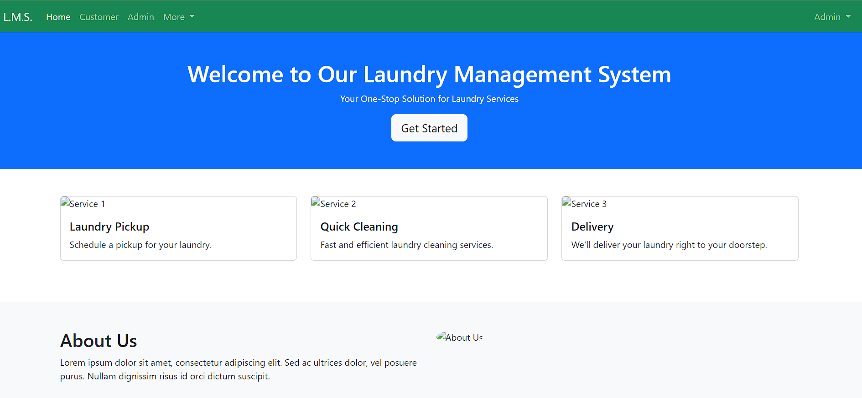

**2). login.html - login page**

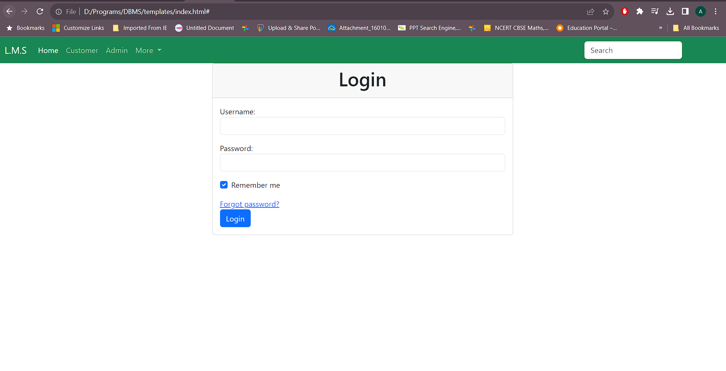

**3). admin.html – Admin Dashboard**

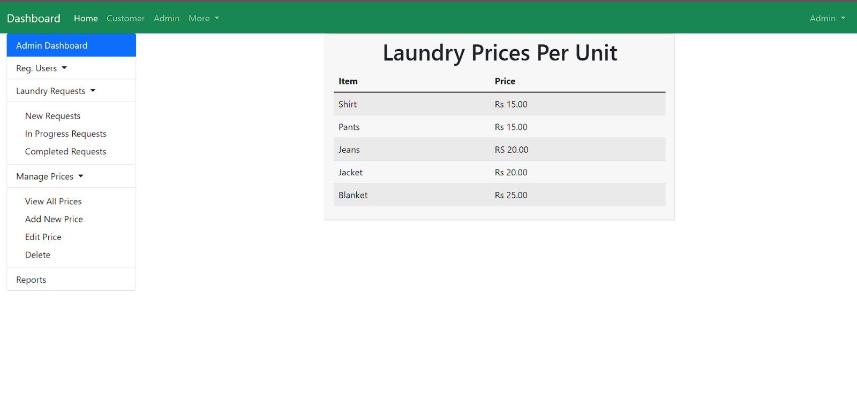

**4). about.html -> About page**

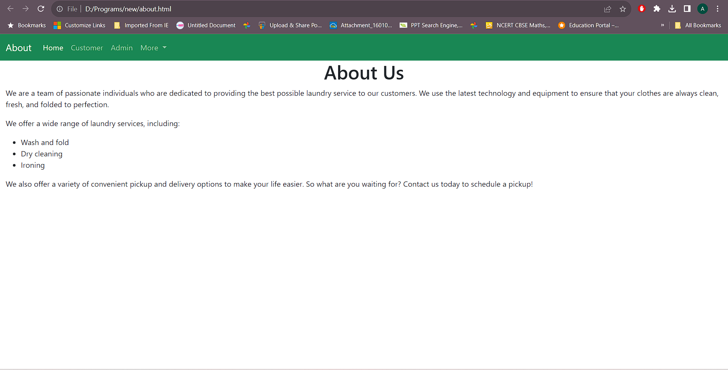

**5). reg.html -> User Registration page**

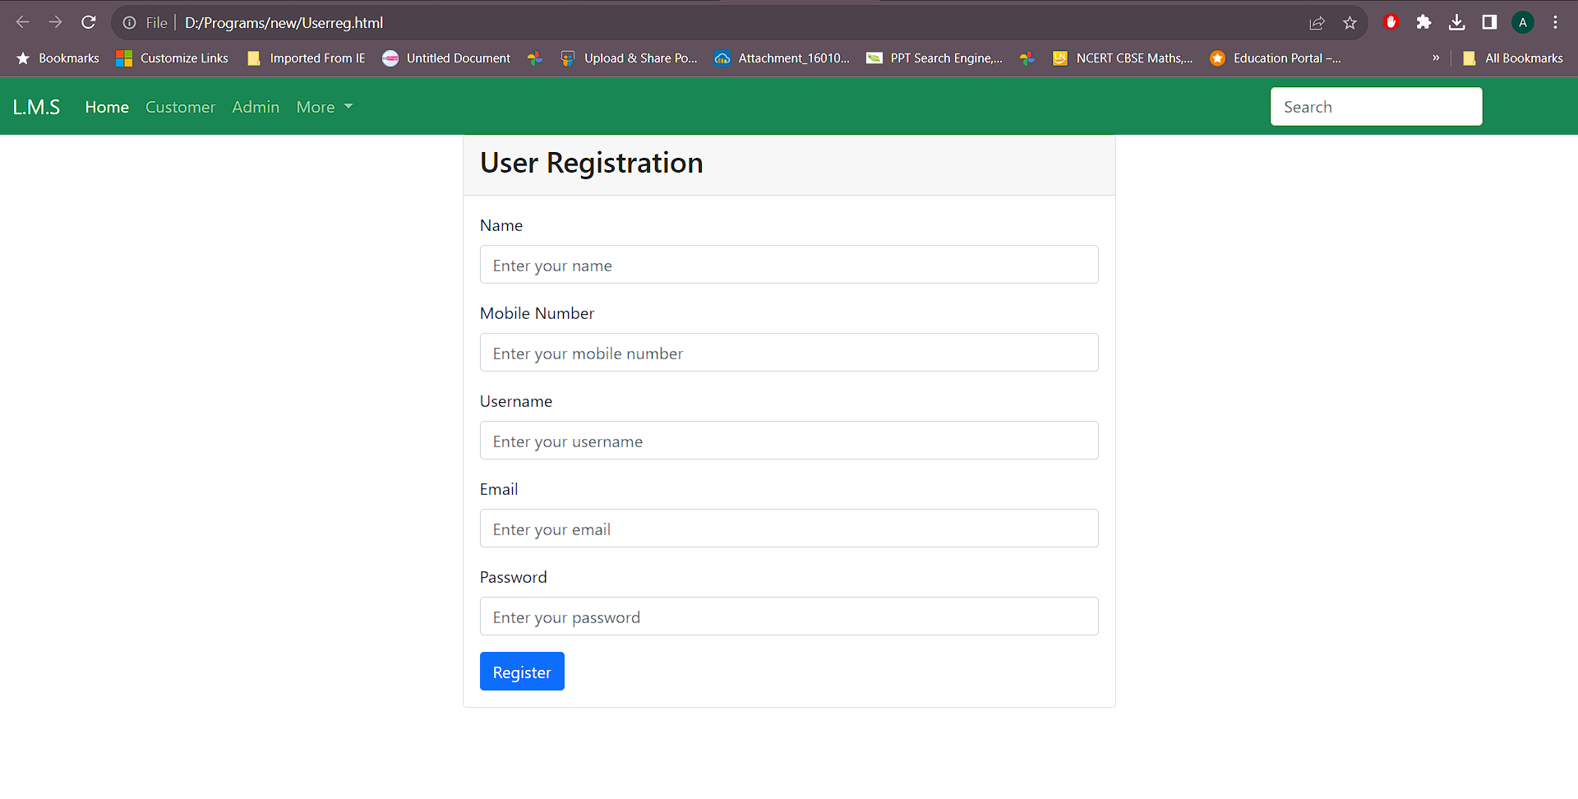

**6). User.html -> User Dashboard page**

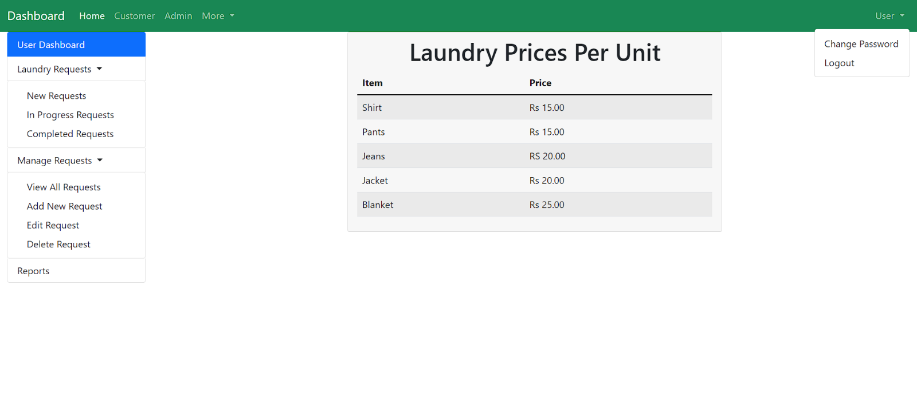

**7). status.html -> Status Check page**

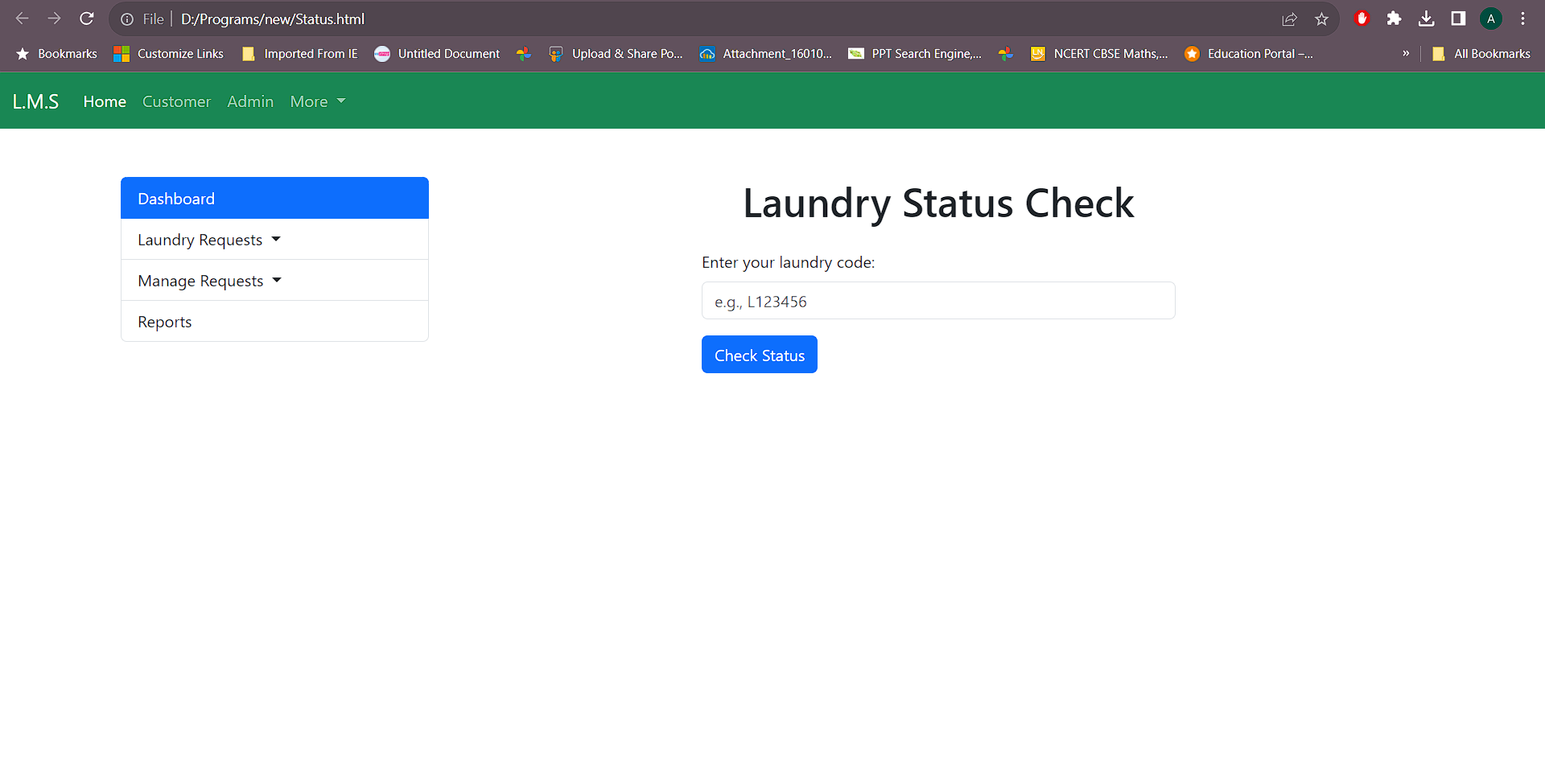

**8). Request.html -> Laundry Request page**

